Shabbos Stories for
The yahrtzeit of
Chana (helen) Keren
Volume 13A, Issue 9 - 28 Tishrei/October 16, 2021
Printed L’illuy nishmas for my mother Chana (Helen) bas Meir

For a free subscription, please forward your request to keren18@juno.com
Past stories can be found on the website ShabbosStories.com

No Opening Day without
Von Tilzer! By Robert Rockaway
The Jewish Tin Pan Alley composer who wrote ‘Take Me Out to the Ball Game’ had never been to a ballgame
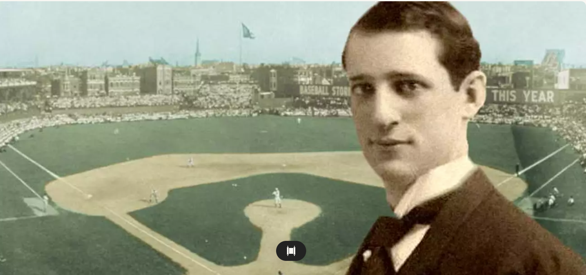
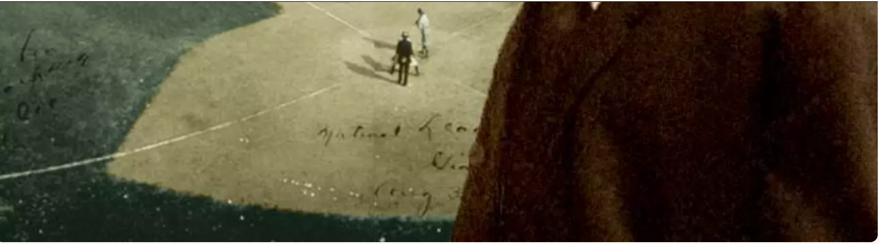

Every baseball fan knows that during the seventh inning stretch, the organ plays and the crowd stands up to sing “Take Me Out to the Ball Game.” But most don’t know that the man who wrote the music was the Jewish composer Albert Von Tilzer, and he had never attended a baseball game.
Baseball fans can sing the first couple of lines of the chorus by heart, but the full song is as follows:

Katie Casey was baseball mad
Had the fever and had it bad;
Just to root for the home town crew,
Ev’ry sou Katie blew.
On a Saturday, her young beau
Called to see if she’d like to go,
To see a show but Miss Kate said,
“No, I’ll tell you what you can do.”
“Take me out to the ball game,
Take me out with the crowd.
Buy me some peanuts and cracker jack,
I don’t care if I never get back,
Let me root, root, root for the home team,
If they don’t win it’s a shame.
For it’s one, two, three strikes, you’re out,
At the old ball game.”
Katie Casey saw all the games,
Knew the players by their first names;
Told the umpire he was wrong,
All along good and strong.
When the score was just two to two,
Katie Casey knew what to do,
Just to cheer up the boys she knew,
She made the gang sing this song:

The song became a smash hit and brought Von Tilzer widespread fame. In 1908, Jack Norworth wrote the original lyrics on some scrap paper while on a subway ride to Manhattan. On the train, he spotted a sign announcing “Baseball Today – Polo Grounds.” He sketched out two verses about a girl named Katie Casey who had “baseball fever.”
He gave the scrap lyrics to his writing partner, Albert Von Tilzer, who composed the music, which was then published by the New York Music Company. Early movie theaters featured it during intermission with the lyrics on the screen, encouraging the audience to sing the chorus. Before the year was over the song had become a hit, and it remained hugely popular through the following decades. Norworth wrote over 2,500 songs, including “Shine on Harvest Moon,” and several other baseball songs. But none is more famous than “Take Me Out to the Ball Game.”

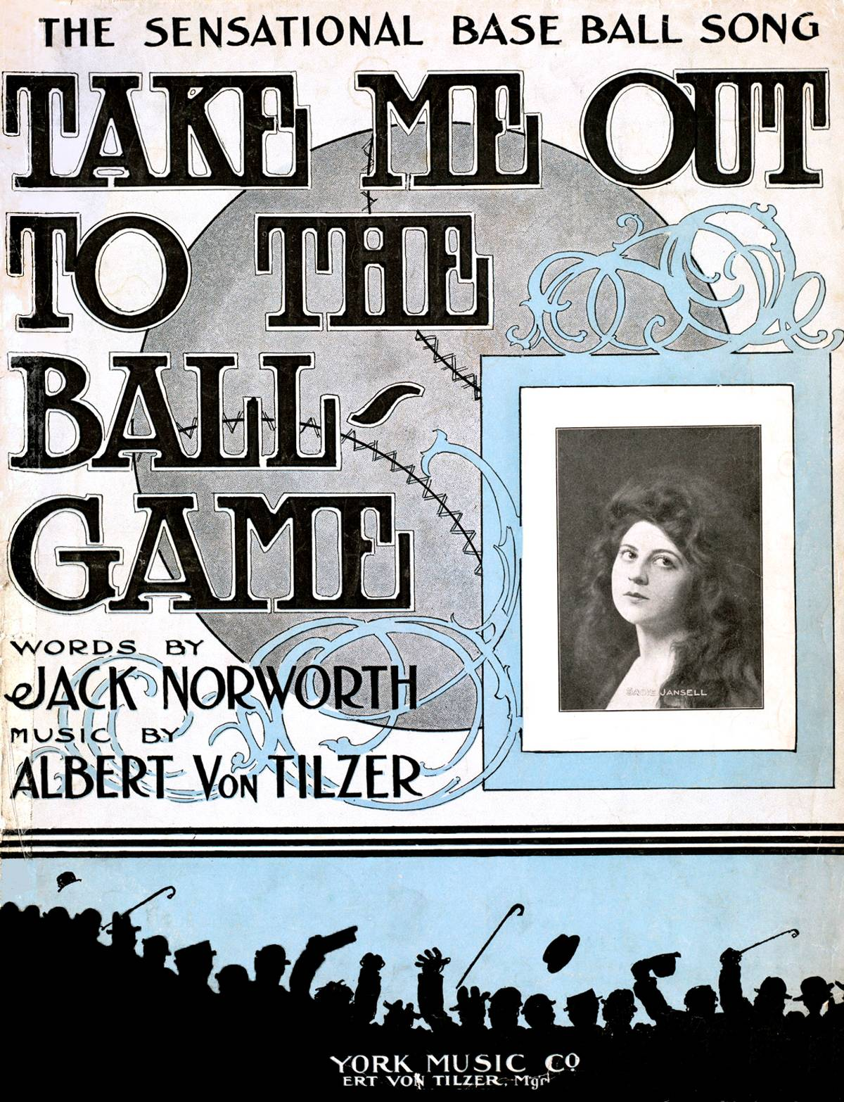
Cover of sheet music for ‘Take Me Out to the Ball Game’

In 1927, Norworth changed some lyrics and a second version appeared. This is the one that is still played and sung during the seventh inning stretch. Norworth finally attended his first Major League Baseball game on June 17, 1940, and saw the Brooklyn Dodgers defeat the Chicago Cubs 5 to 4. On the 50th anniversary of the song’s debut, Major League Baseball presented Norworth with a lifetime ballpark pass.

Originally Born as Albert Gumm
Albert Von Tilzer, the song’s composer, was born Albert Gumm in Indianapolis. One of six sons of Jacob Gumbinsky and Sarah Tilzer, immigrants from Poland, Albert’s father ran a shoe store in Goshen, Indiana, before moving to Indianapolis. The family was quite musical.
Albert’s older brother Harry became a popular songwriter and partner in the music publishing company Shapiro, Bernstein and Von Tilzer, and helped his younger brother land a job at the company’s Chicago office. Albert also assumed the Von Tilzer name and became a prolific Tin Pan Alley songwriter.
Tin Pan Alley was both a cultural concept and a physical place. The physical place was a grouping of apartments, offices, rooms, and spaces located on West 28th Street between Fifth and Sixth avenues in Manhattan. Its ordinary appearance today belies the fact that at the turn of the 20th century, this block embodied a creative and commercial dynamism that had an enormous impact on American music.
It was Harry Von Tilzer who gave the place its appellation. He said that when he walked through the area, the sound of so many pianos being played sounded like people beating on tin pans. Another one of Harry’s creations was the Von Tilzer name itself. He took their mother’s maiden name and added the German nobility particle “Von” to make it sound classier. Four of the five Gumm brothers adopted it.

Hoped to Become a Music Composer
Albert had dropped out of high school to work in his father’s shoe store, but like Harry he also hoped to compose music. After working as a musical director for a vaudeville group, Albert was hired in 1899 as a staff pianist for the Chicago branch of Shapiro and Bernstein. In 1900 he moved to New York City, the center of the music publishing industry.
In order to earn a living, Albert continued to work as a shoe salesman in a Brooklyn department store. Harry then joined Albert in New York, where he opened his own music publishing house, the Harry Von Tilzer Music Company. In 1903, Albert and his other brother Jack formed the York Music Company. From then on it published all of Albert Von Tilzer’s songs, most of which he wrote for individual vaudeville acts in collaboration with Jack Norworth.
“Take Me Out to the Ball Game” made Von Tilzer a pop music superstar. The song was such a success that he received a contract to tour the Orpheum vaudeville circuit in order to publicize it. Although neither Von Tilzer nor Norworth had ever been to a ballgame, the song captured the essence of one quite well. Students of music pointed out that the quarter-rest pause between “take” and “me” in the first measure of the chorus was the perfect spot for the “thwack” sound of a ball hitting a bat.
By the 1920s, Von Tilzer was no longer writing for vaudeville but composing full scores for Broadway. He moved to Hollywood in 1930 to write songs for motion pictures, and retired there in the latter part of the decade.
Two highlights of Von Tilzer’s long career relate directly to his most popular song. On June 27, 1940, the Brooklyn Dodgers baseball club hosted a special day for him at their home park, Ebbets Field. And in 1949, MGM released the musical film Take Me Out to the Ball Game, starring Frank Sinatra, Gene Kelly, and Esther Williams, and in which Sinatra sang the title song, cementing its place in American folklore.

A Last Opportunity to Hear
His Composition Performed
On the eve of the 1956 World Series, Albert Von Tilzer, now a sickly 78-year-old, lay in his Beverly Hills apartment watching television. The Brooklyn Dodgers and New York Yankees were playing, and Ed Sullivan was introducing some of baseball’s greatest stars on his weekly television show. In honor of the impending World Series, the band played “Take Me Out to the Ball Game.” After the show, Von Tilzer’s nurse turned off the television set and tucked him in for the evening. Sometime before morning on Oct. 1, 1956, Von Tilzer died in his sleep.
Albert Von Tilzer was in show business for half a century, and was a charter member of the Association of Songwriters, Composers, Authors, and Publishers (ASCAP), and the Songwriters Hall of Fame. Twenty-four of his songs sold more than 1 million copies. But he is best remembered for one song, the most beloved and well-known musical composition in all of American sports.
Robert Rockaway is professor emeritus at Tel Aviv University, and the author of But He Was Good to His Mother: The Lives and Crimes of Jewish Gangsters.

Reprinted from the March 31, 2021 email of Tablet Magazine.

A Dilapidated Bulgarian Synagogue will become a Cultural Center — and Lifeline
For a Dwindling Community
By Jonah Goldman Kay

The former sanctuary of the central synagogue in Vidin, Bulgaria, built in 1894, is today crumbling and missing a roof. (Jonah Goldman Kay)

VIDIN, Bulgaria (JTA) — For 40 years, the central synagogue in this port city has resembled the town’s Jewish population — barely existent and rapidly aging.
The synagogue, which was built in the 19th century, is quite literally a shell of its former self. Vines creep up the side of the stone walls and the intricate painted designs on the building’s columns have faded from years of exposure to the elements. One of the domes is missing entirely, the result of a World War II bomb. The roof over the sanctuary is missing, too — not that the city’s Jews have use for it. With about a dozen members, the Jews of Vidin can barely form a minyan.
But over the next six months, the synagogue will undergo a massive transformation, gaining a new life as a $6 million cultural center and community hub — for both Jews and non-Jews.

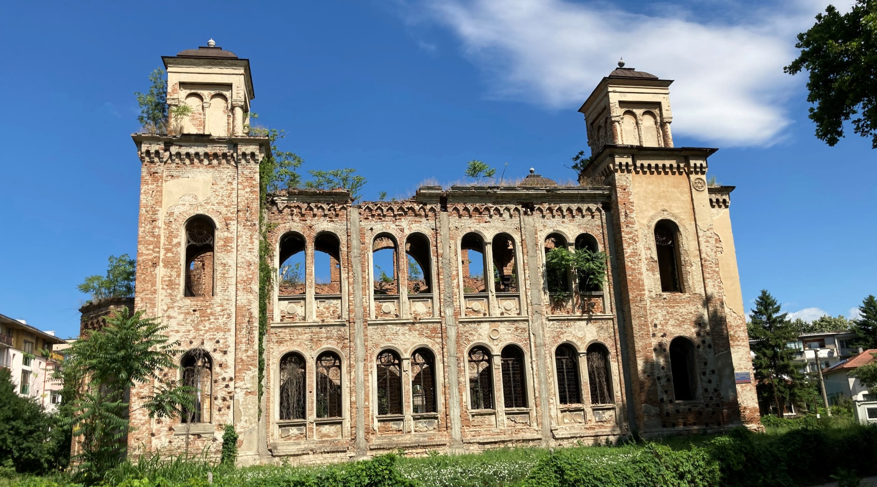
The exterior of the synagogue in Vidin features the outlines of windows in the shape of the Ten Commandments. It was designed by the famed Austrian architect Friedrich Grünanger. (Jonah Goldman Kay)

The Vidin municipality is hoping that the project can do more than restore an old building. The city is nestled in a crook in the Danube River, part of a small chunk of northwest Bulgaria that juts out into a gap between Romania and Serbia. It’s also located in the poorest region in the European Union and, not coincidentally, one of the continent’s fastest-shrinking population centers. (Bulgaria itself holds the ignoble title of the world’s fastest-shrinking country.​​)
It wasn’t always this way.
When the synagogue was built in 1894, Vidin was rapidly industrializing. The Austrian architect Friedrich Grünanger designed the synagogue to be a majestic monument: The two-story building featured a turret on each corner, making it visible from far away. Delicate stained glass and intricate murals covered the interior.
Grünanger modeled his efforts on the Great Synagogue in Vienna hoping that Vidin would one day become as large and powerful as the Austrian capital. At that time, the Jewish community numbered around 1,500 people, or about 10% of Vidin’s population. By the eve of World War II the number had grown to a quarter, or some 2,000 Jews. Vidin’s Jewish community accounted for about 5% of Bulgaria’s overall Jewish population. Sofia, the capital, was home to 50%.

Bulgaria Strongly Encouraged Its
Jewish Population to Immigrate to Israel
Unlike its neighbors, Bulgaria did not deport its Jews during the Holocaust (though it did deport the Jewish population of neighboring Macedonia, which the country occupied during the war). However, after Israel was founded in 1948, Bulgaria strongly encouraged its Jewish population to immigrate to the new Jewish state. Most of Vidin’s Jews acquiesced and left for Israel, leaving behind their war-torn synagogue. By 1949, there were just 17 Jewish families in Vidin, many of whom intermarried and assimilated into the population.
Today that number has dwindled even more. Rosa Marinova, the president of Vidin’s Jewish community organization, estimates that there are around a dozen Jews in town, half of whom regularly attend community events.
“We don’t have a synagogue anymore,” Marinova said. “We’ll get together on Rosh Hashanah and some of the other holidays and do something small, but it’s nothing formal.”
A few years ago, Vidin erected a small monument in the city’s central park to commemorate its once-vibrant Jewish community.

1980’ Attempt to Renovate the Synagogue Failed
With no rabbi and nobody to use the space, the battered synagogue fell into disrepair. In the 1980s, the city attempted to renovate the synagogue with help from Bulgaria’s Ministry of Culture and National Institute of Monuments. But the fall of communism stunted that plan, leaving the synagogue without a roof.
Fully exposed to the elements and abandoned, the already decrepit synagogue fell into complete disrepair. Grass grew over the tiled floor, the iconic metal columns rusted and the walls filled with graffiti from local teens. Although the synagogue was returned to the Bulgarian Jewish community organization in the mid-2000s, the few remaining members had no use for the tottering structure.
“We’d heard for years about how we should be putting effort into restoring this synagogue because it’s considered to be one of the most beautiful in Bulgaria,” said Maxim Delchev, the director of education at Shalom, Bulgaria’s Jewish community umbrella organization. “But, to be honest, we couldn’t put a ton of money into a synagogue in a city that probably won’t have a Jewish community in 20 years.”
So when the Vidin municipality approached Shalom in 2017 with a proposal to turn the synagogue into a cultural center, the Jewish organization was apprehensive but excited. After all, it had just gotten back the synagogue, and the city had already proven itself a negligent steward of the property. However, the fact that the city took initiative and had a concrete plan for restoring the synagogue gave Shalom hope. So did the $6 million in EU funding that had been set aside for the project, part of a larger $1.6 billion project meant to accelerate development in Bulgaria.

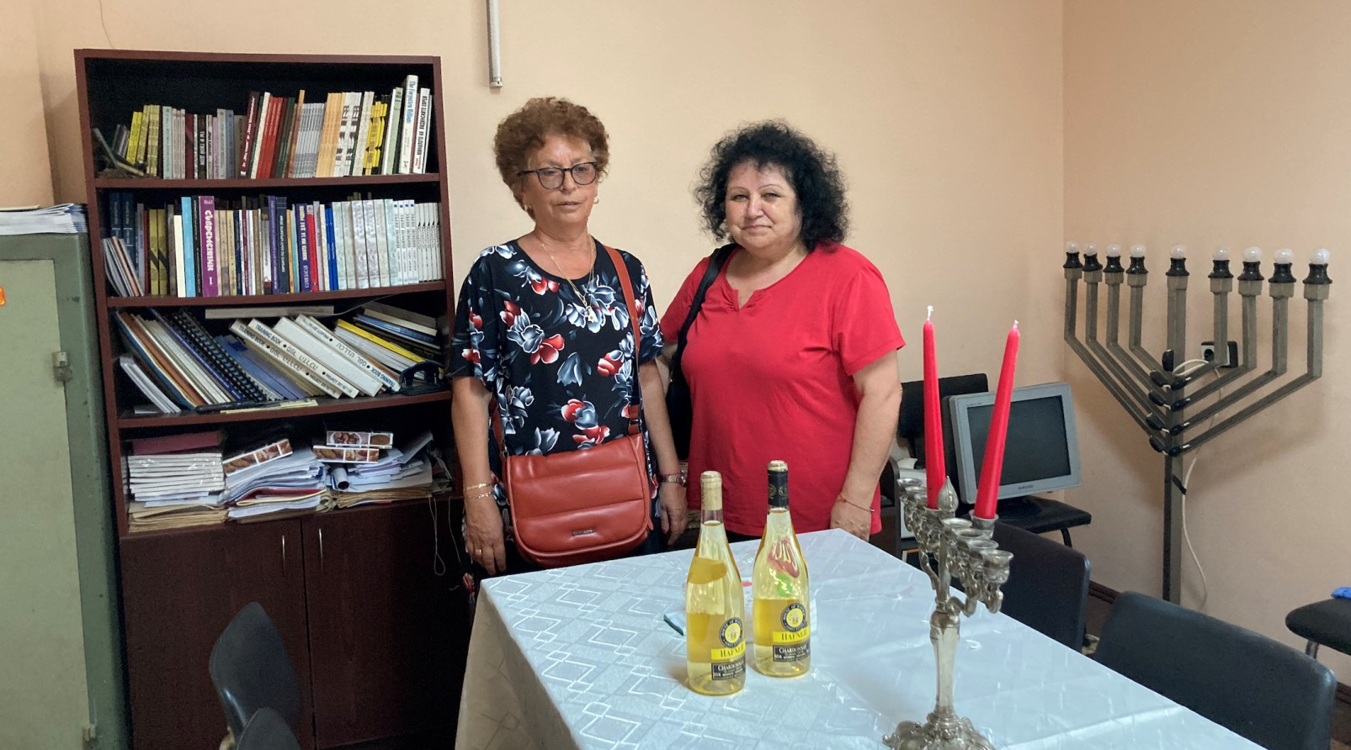
Shelly Vladeva, left, and Rosa Marinova are members of the dwindling Jewish community of Vidin, Bulgaria, which today numbers fewer than a dozen. (Jonah Goldman Kay)

For many in Vidin, the effort to rebuild the local synagogue is their last chance at creating a tourist destination that will revive the cash-strapped region.
“While it’s not going to be used for religious practice anymore, it’ll get a new life as a cultural space,” said Yordan Tsenov, the project’s architect.
Throughout Europe, small towns and cities have turned dilapidated synagogues into cultural spaces, museums, even restaurants, via adaptive reuse. These spaces are usually not designed to be exclusively Jewish. While the Vidin municipality shows genuine interest in preserving Vidin’s Jewish history, it also sees a unique opportunity to bring foreigners — Jewish and non-Jewish — to the city.

Center Named After Jewish Artist from Vidin
Over the next few years, the plan has slowly taken shape. Named after a Jewish artist from Vidin, the Jules Pascin Cultural Center will be home to a museum, performance space, library and cafe. There are plans as well to install a permanent exhibition dedicated to the history of the Jewish community here.
Tsenov said that although the synagogue will no longer be a functioning synagogue, the city plans to restore most of the original architectural features. Most of the early work will involve stabilizing the initial structure, including laying a new foundation and filling in the hollow metal columns with concrete.
In late June, Vidin hosted a groundbreaking event with the mayor and several Jews from the community in attendance. Construction began last month, and the center is expected to open by the end of 2022, barring delays.
“It’s a wonderful building and an important part of our town’s history,” said Shelley Vladeva, another member of the Jewish community. “Everyone in Vidin — Jew and non-Jew alike — want to see it restored.”

No Plans to Use the Synagogue for Religious Services
Even after it opens, the Jewish community doesn’t have any plans to use the synagogue for services. The members will continue to have Shabbat dinners, Rosh Hashanah services and Passover seders at their new community space, a small room near the city’s monument to its Jewish community. It’s much humbler than the synagogue, but it fits their community much better.
Plus, Vladeva adds with a smile, this one is next to the park.

Reprinted from the August 6, 2021 dispatch of the JTA (Jewish Telegraphic Agency).

At the Church of Latter-Day Saints, My Mother’s Moment of Truth
By Rabbi Levi Welton

My mother had very little Jewish upbringing. Her life changed when she had to take a public stand for what she believed. Photo credit: Carlos Arthur M.R., Unsplash.com

My mother was an “Eishet Chayal” – a “Warrior Woman” – long before she knew the meaning of King Solomon’s words that my father sings to her every Friday night. Her childhood touch-points with Judaism were sparse. It was only when she went to the free-thinking and free-loving college campus of U.C. Riverside that her connection to her spiritual heritage truly started to flower.
It was the 1970’s. She was modest by nature, what some frat boys called a “prude”. She initially lived in the women’s dorm and then moved into an apartment with three salt-of-the-earth Mormon female roommates.
They made her feel comfortable – chatting without cussing, abstaining from alcohol and drugs, and not making fun of her for wearing skirts and dresses that comfortably fit her body without uncomfortably advertising it. Their idea of a "party" was having get-togethers where people had pleasant conversations, followed by packing food for charity.
One day, her roommates burst into their flat, shivering with excitement. My mother put down her book and adjusted her glasses. What’s gotten into them? Did one of them start dating a boy? she wondered.
“You won’t believe it,” they told her. “Our Church is choosing a new prophet!”

My Mother Wanted To Know What Happened
My mother had never seen them this excited. “When? What happens?”
They excitedly told her of the “once in a lifetime” moment when a new President, or “Prophet”, of the Church of Latter-Day Saints is chosen. Swept up in the rush of youthful zeal, my mother found herself agreeing to join them on the road trip from California to Utah, headquarters of their faith.
Why not? she told herself. She was an inquisitive person and what better way to explore a culture than with a literal front-row seat. And if anything goes wrong, I can just shut my mouth and keep my head down and no one will notice me. This introverted life-approach had served her well so far, hiding her sensitivity and intelligence from intimidating people, especially men, who teased her for it.
But 663 dust-blown miles and many changes of outfits later and my mother found herself trapped. She was sitting in the third-row balcony of a castle-like hall, surrounded by thousands of believers and dozens of national and international media cameras and reporters. Someone had just announced that all those who believed the imminent Mormon president to be the “only true Prophet on Earth” should – when called upon – stand up and lift their palm towards a small, blue-sky filled, square window in the ceiling as testimony to the One Above in all things.

Her Yiddishe Neshama Woke Up
And that’s when my mother’s Yiddishe neshama (Jewish soul) woke up. You don’t believe in this, so you can’t do this. You must be honest, an inner voice told her. My mother glanced around, looking for a way out. But she was jammed in between her two friends. And on either side of her, crashing towards her was a wave of hands being lifted in the air, highlighted by bolts of bright sunlight from the tall windows.
Maybe she should stand up but keep her mouth shut, or raise her palm but keep her head down. Maybe slink lower into her chair and pray for a miracle that no one notices her. She was experiencing the introvert's worst nightmare.
Her heartbeat zoomed into overdrive. And as the color crimson filled the capillaries in her translucent cheeks, she remained seated, even when she realized that all the people below were looking up at her section, and at her, at the one person sitting. The news cameras zoomed in to capture her face. Shocked whispers and furious note-scratching of journalists assaulted her from every angle. She shut her eyes and felt the heat of shame.
Her picture was later featured in international magazines, with commentary speculating who was this mysterious woman who remained sitting. My mother wondered what hell-fire her roommates would receive from their church and friends. But back in their hotel room, they consoled her and said, "You shouldn’t do what you don’t believe."
My mother told me, “My roommates supported me; they had my back.”
By the end of her college years, my mother was attending regular Shabbat services. Upon graduating with a PhD in Microbial Genetics, she stepped out of the rat race to attend Machon Chanah, a women's seminary in Chassidic Brooklyn.
My mother, my teacher, embodies the ideals of the Jewish woman of valor. She’s a warrior not defined by the glorification of violence but by the moral nobility of her values.
Her bold moment of shame for staying committed to her Truth and her fierce courage to live authentically makes me so proud to call her my mother.

Reprinted from the Parshat Shotim 5781 website of Aish.com

VIP Service
By Rabbi Yoel Gold

Rabbi Yoel Gold

During 2014’s Operation Protective Edge, Benyamin Moss, a high school teacher in Baltimore, was one of many Jews who sought out a connection with soldiers in the IDF. A hotline had been set up to distribute names of Israeli soldiers so that people could daven for them, so Benyamin called in. He was assigned to daven for Eitan ben Edna.
The Gaza ground invasion began on Thursday night. Benyamin did his due diligence, mentioning Eitan ben Edna during Maariv, and then at Shacharis Friday morning. But when he sat down to breakfast after davening, he discovered that one IDF soldier had already been killed — First Sergeant Eitan Barak, fatally shot by a Hamas gunman in North Gaza at 3 a.m. Could this be his soldier?

But the Mother’s Name was Fairly Uncommon
He frantically searched news sites for Barak’s mother’s name, only to come up empty. Eitan is one of the ten most popular names in Israel, but Edna is fairly uncommon, so Benyamin decided that unless someone presented him with further evidence, he would continue to daven for “his” soldier until the war was over. He stored “Eitan ben Edna” in his phone’s memory, including the boy in his tefillos three times a day, but privately doubted that it made a difference. He had a bad feeling about it.
Eventually the danger subsided, and Israel withdrew from Gaza. Months passed, eventually years. This summer, Benyamin decided to spend some time in Eretz Yisrael. He had not been there since Operation Protective Edge, and a visit was long overdue.
The Kosel, Me’aras Hamachpeilah, a couple of good hikes — the itinerary was carefully planned, except for one thing. Benyamin wanted to get a brachah from Rav Chaim Kanievsky, but he’d heard that it was really, really hard to get an audience. He did have a secret weapon, though — his grandmother lived in Eretz Yisrael, and she had connections. He called her up, hopeful. Did she know of anyone who could help him get in?

Recommended that He Try Tzvika Cohen
“Of course,” she said. “Have you tried Tzvika Cohen? He’s a big macher over here with access to all the gedolim. Just call him and tell him I sent you.” She gave Benyamin the number.
Benyamin called Tzvika and explained the situation.
“Sure, no problem,” Tzvika said easily. “I can get you in to Rav Chaim. When are you arriving? Give me your flight number. Call me when you get here.”
Benyamin took his phone number, writing it in an address book. He’d be leaving his American phone behind for the few weeks of his vacation. There were other things to pack: his clothing, some sefarim, gifts for family members in Israel. The days flew by, and soon he was about to leave.
On his way out the door, Benyamin took one last look at his phone – Eitan ben Edna, that’s right. He’d heard the stories of chutznikim meeting their assigned IDF soldiers in Israel and seen the InspireClips video about a woman who traveled to Israel, and, through a series of seeming coincidences, went to a restaurant and met the soldier the had prayed for. Wouldn’t it be funny, he thought, if he met someone who’d known his??
The plane landed in Ben Gurion Airport, and Benyamin collected his carry-on items. He followed the other passengers up the aisle of the plane, into the jetway, and joined the slow-moving crowd making their way to passport control and customs. Just inside the terminal, VIP escorts waited, brandishing signs with their passengers’ names. To Ben’s surprise, one of them held a sign reading “Benyamin Moss.”

A V.I.P. Sign for Benyamin Moss
“Uh, I’m Benyamin Moss,” he said. “Who are you?”
“Shalom,” the escort said. He was a tall young man in his early twenties and spoke in accented English. “This guy Tzvika ordered VIP service for you. They sent me to pick you up. I’m going to take you through passport control and get your luggage.”
That was a luxury service Benyamin hadn’t been expecting. The escort took his bags, sat him in a “golf cart,” and began to drive, bypassing the walkways and crowds. When they reached the fast-track section of passport control, they both got out of the cart, with the escort taking Ben’s carry-on items. “Thank you very much,” Benyamin said. “Uh, what’s your name?
“Ah, I’m sorry, I forgot. I’m Eitan.”
Benyamin smiled at the coincidence. “Did you serve in the army?”
“Betach, of course.”
“In Tzuk Eitan?” Benyamin asked, referring to Operation Protective Edge by its Hebrew name.
“Yes…” Eitan said slowly.
Ben’s heart was beating quickly now. “This is going to sound very weird, but what’s your mother’s name?”
Eitan looked at him strangely. “Her name is Edna. Why do you ask?”
Reprinted from the website of Hidabroot.com Rabbi Yoel Gold, rabbi of congregation Beis Naftali in Los Angeles, California, and a ninth-grade rebbe at Yeshiva Mesivta Birkas Yitzchak, has inspired hundreds of thousands of people with his stories through his popular video series. To watch some of his videos or to share your story with him, please visit InspireClips.com.

